* 1. **Design like powerpoint :**

**In 2*2 cell means B,2 we increase height of 2 and decrease width of A and font color filler and size is done.**

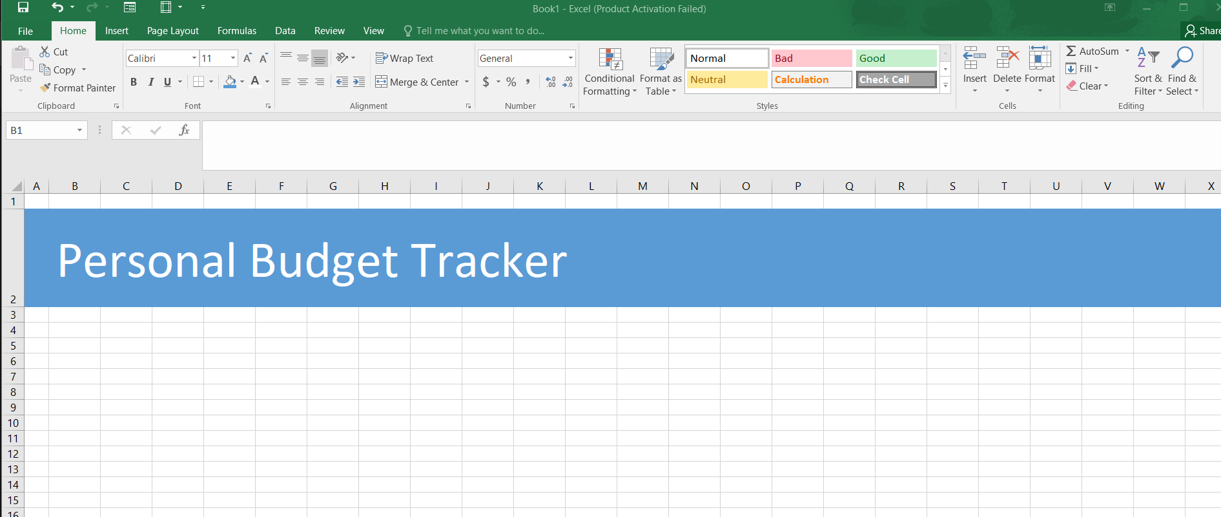

**1.Shape diye design korbo power point er moto and text er jonno alada box lagena auto dewa thake excel e shape ei**

**2.ctrl+mouse er left diye drag and dop diye duplicate kore**

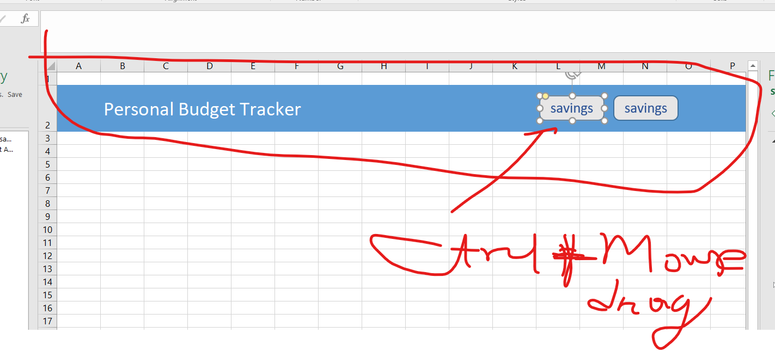

**1.2 Table Design: Shob column banaye 1 ta extra row niye select korbo**

**Ctrl+t notification ashle My table has header e tik boshabo then iccha moto design nibo**

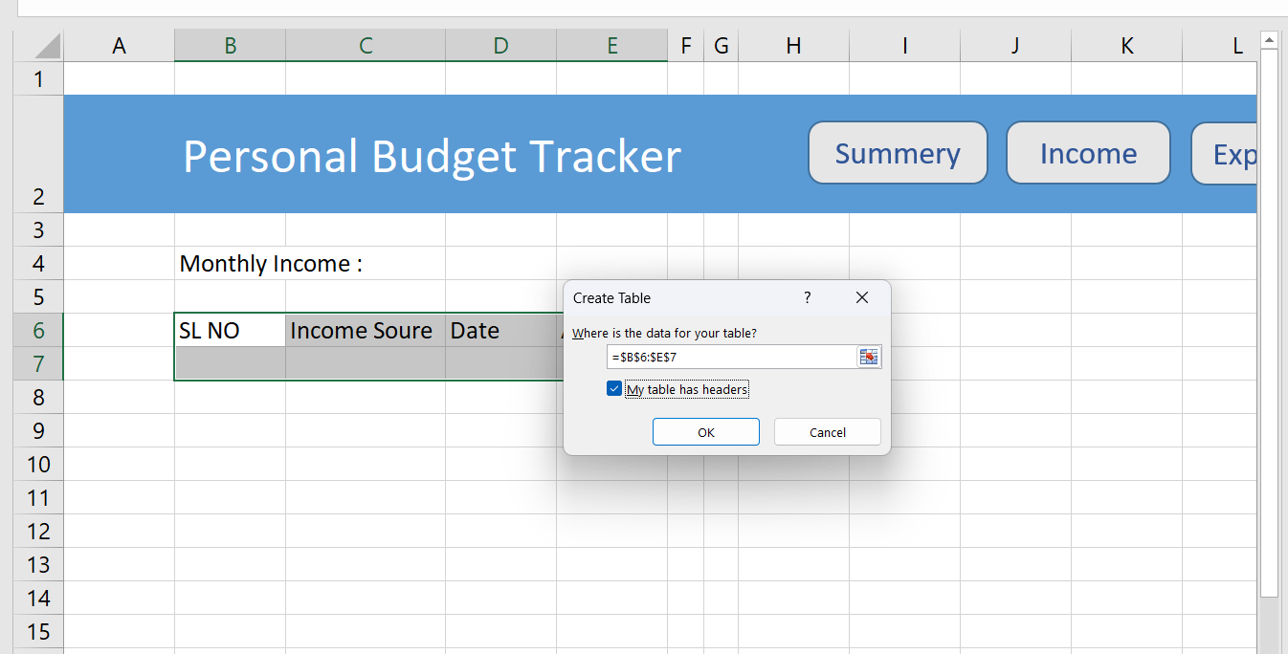

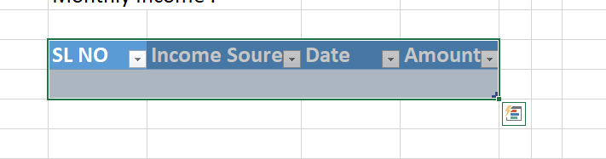

* 1. Create a copy of sheet

**Sheet Income er upor mouse right click korle option ashbe**

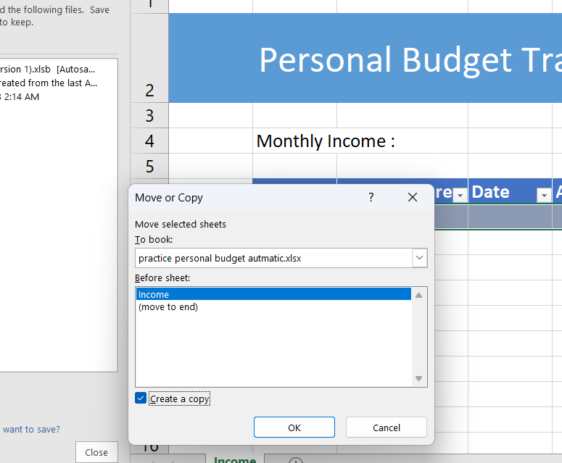

* 1. Increase wide of date cell in saving,expense and income sheet at once

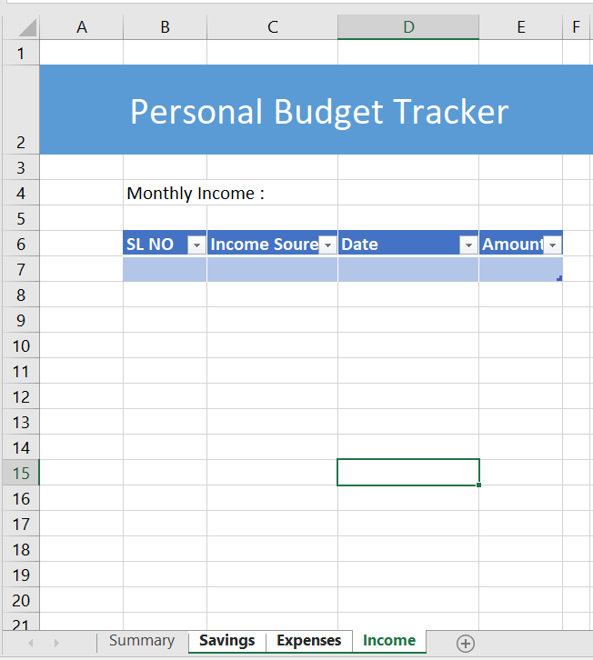**Ctrl+ select all sheet then wides the cell**

* 1. **Button er shathe sheet gular link korbo hyperlink diye**

**Income er Shathe Income ,ebhabe shob gular shathe shob gula**

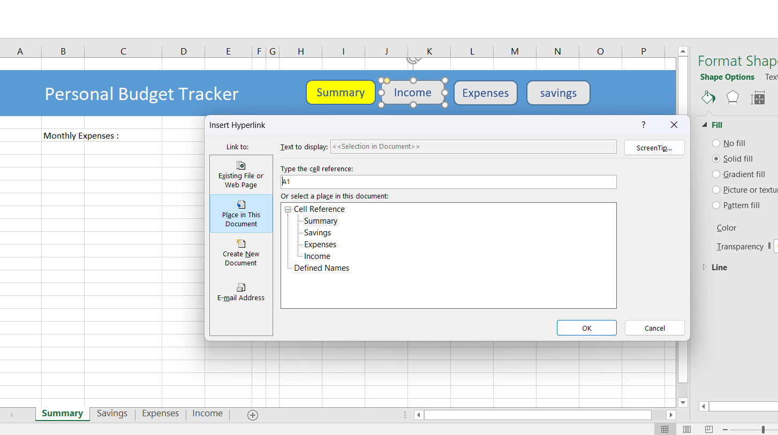

* 1. **Shortest way of sum**

**=sum( diye rekhe expenses er celle jeye expense column select kore enter korbo just**

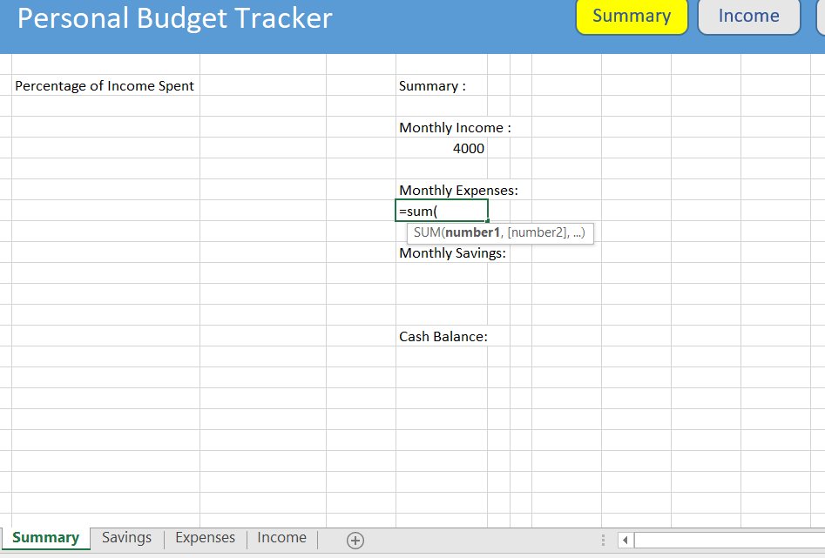

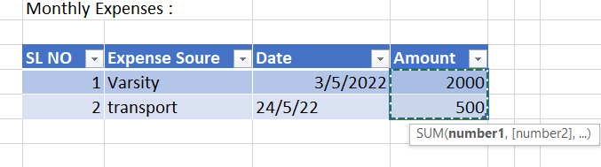

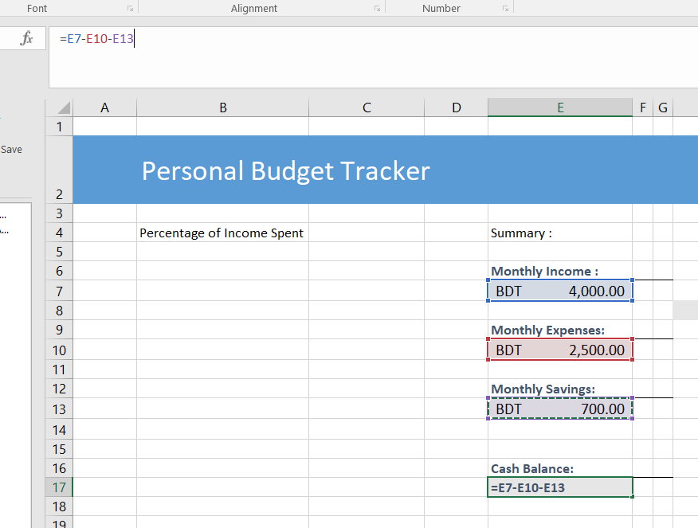1.7:Cash Balance ber kora

Ekhane cell select kore cntrl diye cell er address pich kore – korte thakbo income theke

1.8 2 D blank column chart e data select

Shurute right click kore data select option e jabo then add e click kore then series name dibo and value dibo sum er cell   
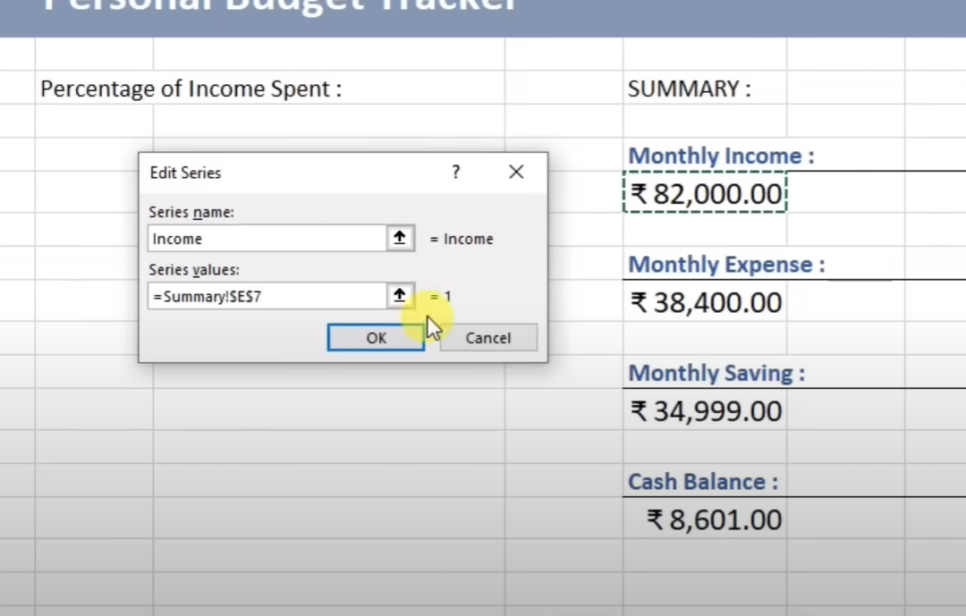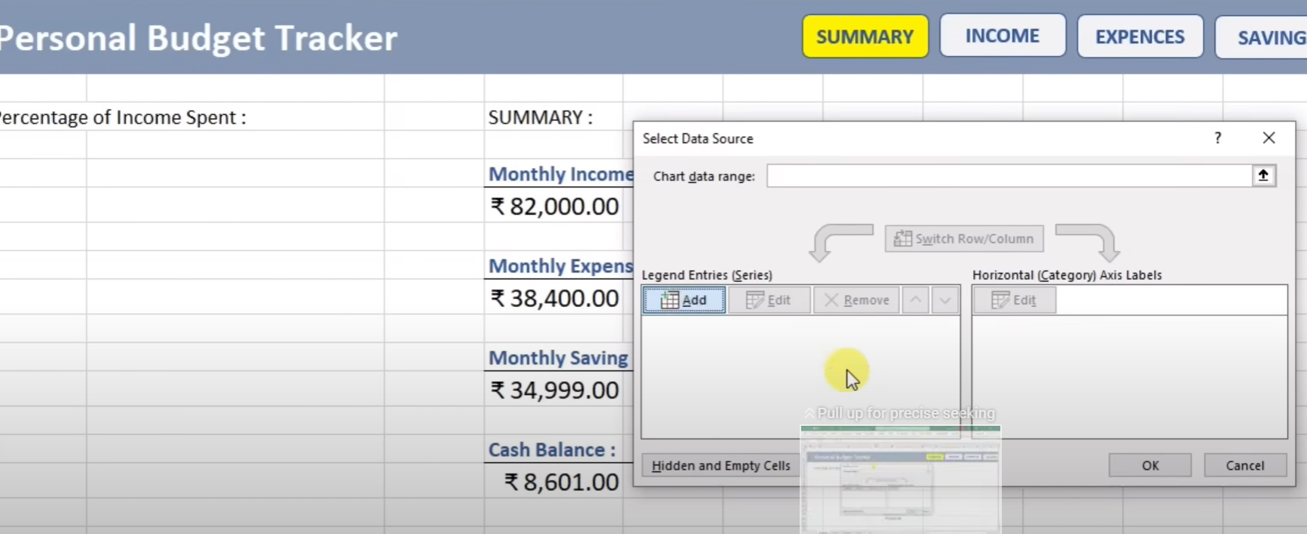

**1.9 Percentage of Income Spent:**

**1.Total Expense/ total income and then % it**

**2.Cash and savings 1-spent percentage**

